【例2-97】已知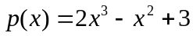，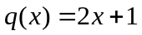，求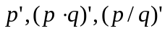
>> k1=polyder([2,-1,0,3])
k1 =
6 -2 0
>> k2=polyder([2,-1,0,3],[2,1])

k2 =
16 0 -2 6
>> [k2,d]=polyder([2,-1,0,3],[2,1])

k2 =
8 4 -2 -6
d =
4 4 1

